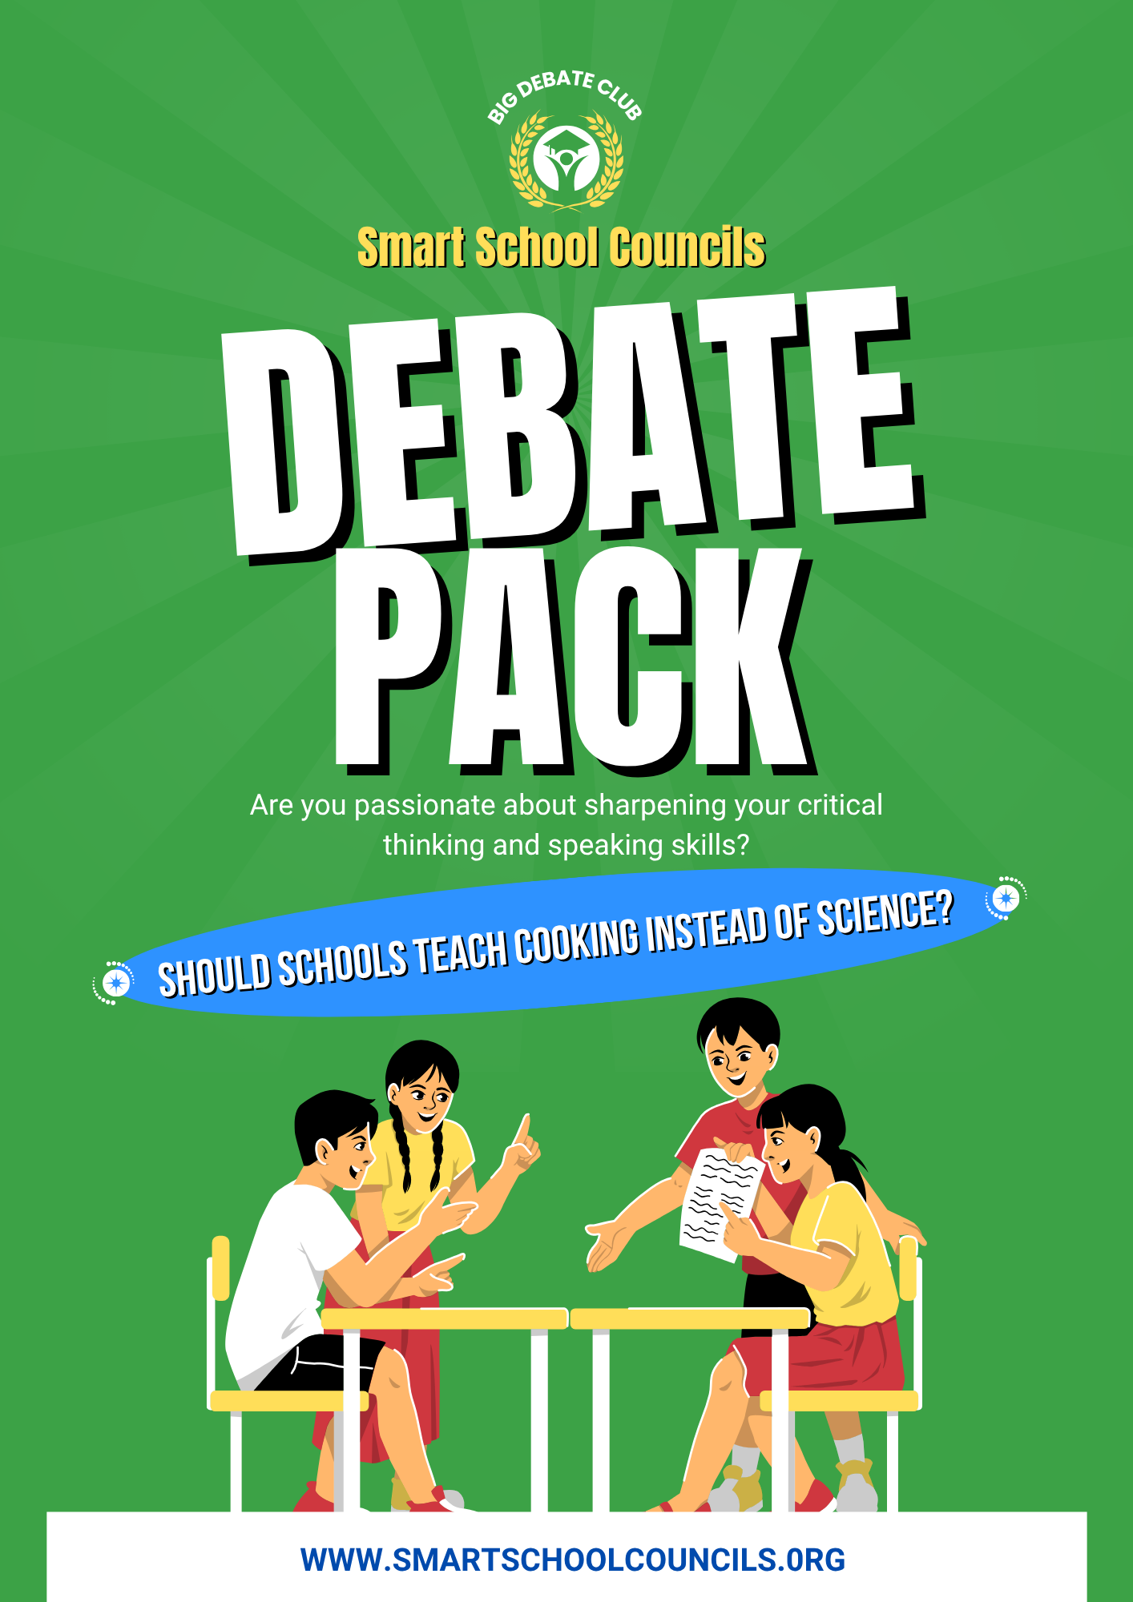

How to Use this Debate Pack

Whether you have just a few minutes or a full lesson, this Debate Pack has got you covered. Check out the Certificates at the end too.

How to find the debate video and send to teachers
- Log in to the Smart School Councils platform using your school details.
- Click on the blue Class Meeting Tool button in the dashboard.
- Click on 'Next Meeting' at the top of the page.
- To get started, click on 'click here' to browse existing questions and options.
- If the debate topic is part of this week's question, it will appear there. Otherwise, click 'Search All' and type in the debate topic you’re looking for.

Got five minutes?
Play the debate video straight through and dive right into the debate. No need to pause at the prompts. It’s a quick, engaging way to get your students thinking.

Got 10/15 minutes?
Pause at the prompts in the video to explore additional ideas your class might have. Use the additional points or Power Facts if you’d like.

Want to extend to 30 minutes or a full lesson?
Check out the lesson plan and writing tasks below. There is also a full Fact Sheet with amazing further reading if your students want to go deeper on the topic.




What do the icons in the pack mean?

This is what the presenter says on the video

This is a Power Fact to explain or prompt debate that’s not in the video

This is an additional debate point that’s not in the video

Introduction and Brain Gym Question

Introduction
Welcome to Big Debate Club!

My name is Becky and today we are debating the question…

Should schools teach cooking instead of science?

School is all about giving you all the knowledge and skills that will prepare you for whatever future you want. So which would be more beneficial for your future - learning about cooking or learning about science?

Some people argue that cooking is an essential life skill and should have more time in the school timetable. Others believe science is too important to replace because it helps students understand the world and prepares them for future careers. But which should be taught? You decide.

Brain Gym Question
Before we get started with the debate, I have a question for you…

Which of these areas of everyday life uses science?
a. Cooking
b. Medicine
c. Weather forecasting
d. All of the above

Cooking and science aren't opposites! Cooking involves chemistry, biology and physics. For example, heating food causes chemical and physical changes that affect its colour, texture, smell and taste. According to the Royal Society of Chemistry, there are more than 100 million known chemical substances, showing the enormous scale of chemistry, which is involved in many everyday processes, including cooking. (Source: Royal Society of Chemistry, LINK)

FOR: Schools should teach cooking instead of science

We’re going to share reasons for both sides of the debate, then it’s up to you to think of the rest!
Cooking is an important life skill
You might be thinking that cooking is an important life skill. Everyone needs to eat, and knowing how to prepare simple meals that are good for you can help people become healthier and more independent when they are older. A 2024 survey by the British Nutrition Foundation found that only around 1 in 5 young people aged 11–16 reported cooking a meal from scratch every day. So learning this important skill at school would mean more would be able to develop this skill to enable a better life.

A packed itinerary full of active things to do can be good for you
You could say that cooking can help young people be healthier. Cooking lessons can teach students about ingredients, nutrition, food preparation and making balanced choices. The NHS estimates that more than 15% of children and adolescents aged 2–15 were overweight in 2024. Learning how to prepare food and understand what goes into meals could help young people develop healthier habits.

Can you think of another reason why you might argue that school should teach cooking instead of science? ⏸️

Cooking can help at home and bring people together
Whether young people can help with cooking chores at home to help their family but also it can give an opportunity to eat well together as a family or community. Research published in the Journal of Nutrition Education and Behaviour found that family meals were associated with healthier dietary patterns among children and teenagers. (Source: Journal of Nutrition Education and Behaviour, LINK)

Cooking can develop other skills like money skills
Preparing meals at home can be a useful way to learn about budgeting, comparing prices and reducing food waste. By learning how to use money effectively through buying ingredients for home cooked meals then planning how we can use everything up, we can avoid the huge amounts of waste produced in the UK. According to WRAP, UK households waste around 6.4 million tonnes of food each year. (Source: WRAP, LINK)

AGAINST: Schools should teach science instead of cooking

Now let’s change positions and consider why you might argue that schools should teach science instead of cooking.
Science is important to understand and solve major problems
You might think that science is important to learn to understand and solve major problems. Science isn't just about memorising facts. It helps us understand things such as climate change, diseases, energy and technology. Scientific knowledge can also lead to new discoveries and careers. Removing science from schools would mean young people lose an important foundation for understanding the future.
A lot of important jobs need scientific knowledge
Or you could also say a lot of important jobs need scientific knowledge. Doctors, engineers, scientists, environmental specialists and many other professionals depend on scientific knowledge. The UK government identifies science and technology as critical to the UK's future and estimates that around 7 million people work in science based jobs in the UK. Replacing science with cooking could limit students' opportunities to have the knowledge needed for their future careers.

Can you think of another reason why you might argue that schools should teach science instead of cooking? ⏸️

Science helps us understand what is going on with the planet
Science helps us understand what is happening to our planet and why the climate is changing. By studying science and learning about climate change, young people can become scientists of the future to make the planet better. Scientists say the Earth's average temperature was about 1.1°C warmer in 2011–2020 than it was around 1850–1900. (Source: IPCC, LINK)

Learning about science can save lives
Science is behind many medicines and vaccines that protect people from serious diseases. By learning biology through science lessons, we can literally save millions of lives through the development of things like vaccines. The World Health Organization estimates that vaccines prevent around 3.5–5 million deaths every year. (Source: OECD, LINK)

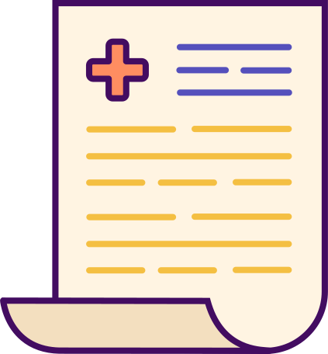
FactSheet: Should schools teach cooking instead of science?

Here’s six key facts - three on each side - if you’d like to go a little deeper.
Teach cooking instead of science
Cooking can develop other skills like money skills
Preparing meals at home can be a useful way to learn about budgeting, comparing prices and reducing food waste. By learning how to use money effectively through buying ingredients for home cooked meals then planning how we can use everything up, we can avoid the huge amounts of waste produced in the UK. According to WRAP, UK households waste around 6.4 million tonnes of food each year. (Source: WRAP, LINK)

Cooking can help at home and bring people together
Whether young people can help with cooking chores at home to help their family but also it can give an opportunity to eat well together as a family or community. Research published in the Journal of Nutrition Education and Behaviour found that family meals were associated with healthier dietary patterns among children and teenagers. (Source: Journal of Nutrition Education and Behaviour, LINK)

Cooking can make you more independent when you are older
Knowing how to prepare food can help young people become more independent as they get older. A survey by the British Nutrition Foundation found that around 70% of young people aged 11–16 said they had prepared food or cooked something themselves, and with more opportunity to practice at school can mean more can do this daily. (Source: British Nutrition Foundation, LINK)
Teach science instead of cooking
Science helps us understand what is going on with the planet
Science helps us understand what is happening to our planet and why the climate is changing. By studying science and learning about climate change, young people can become scientists of the future to make the planet better. Scientists say the Earth's average temperature was about 1.1°C warmer in 2011–2020 than it was around 1850–1900. (Source: IPCC, LINK)
Learning about science can save people’s lives
Science is behind many medicines and vaccines that protect people from serious diseases. By learning biology through science lessons, we can literally save millions of lives through the development of things like vaccines. The World Health Organization estimates that vaccines prevent around 3.5–5 million deaths every year. (Source: OECD, LINK)

Science can lead to important future careers
Science is important for careers such as medicine, engineering, environmental science and scientific research. The UK Government estimates that there are around 7.3 million people working in Science-related occupations in the UK. (Source: UK Government, LINK)

Sentence Starters

POINT
LEMON & HERB: One reason why I (agree/disagree) with this debate is because…
MEDIUM: One point I have for this debate is…
HOT: You could say that…

EVIDENCE
LEMON & HERB: One way I can prove my point is through this example…
MEDIUM: I can show this works through the fact that…
HOT: I know this because…

EXPLANATION
LEMON & HERB: The evidence I have discussed above proves my point as…
MEDIUM: This example proves my point because…
HOT: Therefore, this proves my point as…

LINK
LEMON & HERB: All together, this answers the debate question asked by…
MEDIUM: This point answers the overall question because…
HOT: These ideas answer the debate as…

